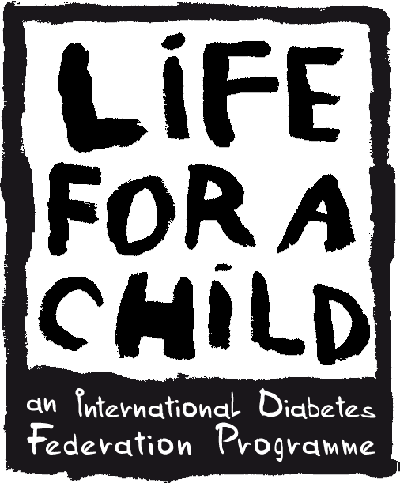

LIFE FOR A CHILD SUGGESTION FORM

IDF MEMBER

Name of IDF member association
Country
Contact person
Email address

SUGGESTED LOCATION FOR LIFE FOR A CHILD IMPLEMENTATION

Country
Name of organisation/
clinic/hospital/ etc.
Contact person (Full Name)
Email address
Address
City
Number of Type 1 diabetes patients under the age of 26
Existing Infrastructure | ☐ Medical refrigerator(s)  ☐ Secure medicine and medical equipment storage  ☐ Secure patient data record system  ☐ Sharps containers for safe disposal of needles  ☐ Other:
Staff composition | ☐ Administrative staff:  ☐ Diabetic Educator(s):  ☐ Qualified nursing staff:  ☐ Dietitian(s): | ☐ Endocrinologist(s):  ☐ Pediatrician(s):  ☐ Other:
General comments on diabetes services on site | In this field, please elaborate on the services offered at the centre.
RESOURCES REQUIRED PER PATIENT (UNDER THE AGE OF 26) PER YEAR

Number of insulin vials required per patient per year | Number of glucometers required per patient per year | Number of strips required per patient per year | Number of syringes and needles required per patient per year | Number of lancets required per patient per year | Number of HbA1c controls required per patient per year

REASONS FOR YOUR CHOICE OF SITE
In this field, please give us your reasons why you think that this site should benefit from the programme.

