EPNS Research Meeting 2014

12 / 13 Sep 2014
Bucharest – ROMANIA
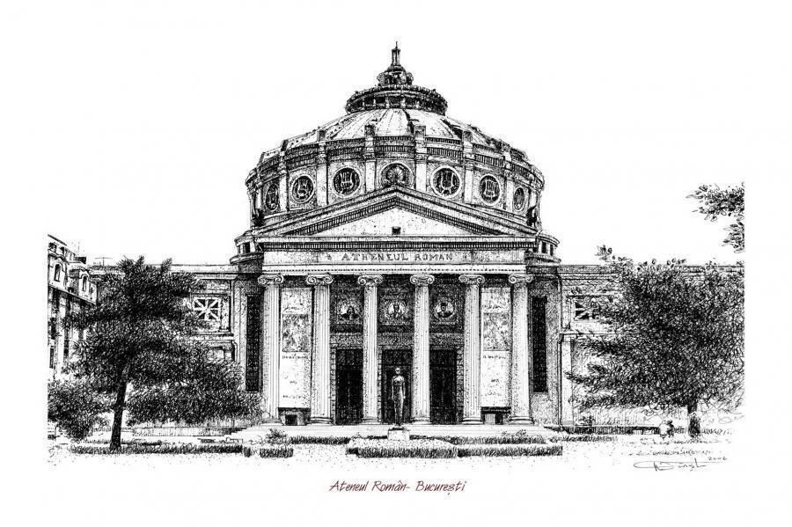
Main topics for talks:
Topic 1 Dystonia
Topic 2 European grants and networking

Research groups:
- ADHD
- Ataxia
- Autoimmune-inflammatory diseases
- Developmental Neurology
- Epilepsy
- Neonatal Neurology; Neurodegeneration and Neuroprotection
- Neurometabolic session (markers, networking, diagnosis)
- Neuromuscular diseases
- Movement diseases

DEAR COLLEAGUES,

We are very happy to invite you to the 4th EPNS Research Conference which is to be held in Bucharest , Romania, 12-13 September 2014 at the Intercontinental Hotel Bucharest, in the very heart of Bucharest.
The Research Conference is organised by the EPNS, CEA-ILAE, SRNP (Romanian Society of Pediatric Neurology), with the help of RONEP (Romanian Foundation of Neurology and Epileptology) and Rotary Club OCTO Bucharest.
EPNS Research Conference is a forum for researchers in the area of Paediatric Neurology, where they present their work, ideas, results, creating the possibility for good interaction between researchers and premises for networking, future collaborative research in Europe and beyond.
As usual, there will be 2 plenary sessions and 8 parallel working groups where the most experienced professionals and young researchers will get together, in an environment where interactive, vivid discussions will take place around the presented topics.
At the final discussion each group will present their working group summary.
Publications of the working groups’ discussions and conclusions may follow.
Bucharest is a cosmopolitan place with a beautifully restored old city located 10 minutes walk from the Conference venue.
We hope you will enjoy your stay in Bucharest from both a scientific and leisure point of view!

Looking forward to meeting you in Bucharest!
Dana Craiu
Local Organiser

DEADLINE FOR EARLY REGISTRATION
1 August 2014

BURSARIES
14 bursaries of 500 euro each (10 from the EPNS for any working group and 4 from CEA ILAE for the epilepsy working group) will be offered to young investigators. Bursary request, CV, recommendation from head of the department should be sent to flore.ronep@yahoo.com Bursary applications can be accepted from everywhere in the world. It is a condition for receiving a bursary that applicants must be presenting a project or their work at the Research meeting. If more than 14 applications are received, priority will be given to the youngest applicants. Deadline for receiving bursary applications is 1 July 2014. Applicants will receive a response by 15 July 2014.

EPNS RESEARCH PRIZE
There is an EPNS award at every research conference The EPNS Research Prize (2500 euro) this year will be awarded to two young neurologists who present an outstanding, innovative idea in the area of research in Pediatric Neurology. A commission of the board members will decide the prize recipients.

PROGRAM PAEDIATRIC NEUROLOGY RESEARCH CONFERENCE
The Research meeting is structured around group discussions which represent the main part of the conference. All groups will work in parallel.
Two main topics for lectures are decided every year by Scientific Committee of the EPNS board.

The draft structure of the programme is as such:

Friday, September 12, 2014
12.00-13.00 | Arrival Registration Lunch
13.00-13.15 | Welcome
13.15-14.15  14.15-16.30  16.30-17.00  17.00-19.00  19.30 | Plenary Lecture 1 Dystonia  Working groups 1-8  Coffee Break  Working groups 1-8  Get together and Dinner

Saturday, September 13, 2012
08.30-09.30 | Working groups 1-8
09.30-10.30 | Plenary Lecture 2 European research and grants
10.30-11.00 | Coffee Break
11.00-13.00 | Presentations, discussions and conclusions of the working groups 1-8
13.00-13.15  13.15-13.30  13.30 | Award of the EPNS Research Prize  CONCLUSIONS  Lunch/Farewell

If you would like to participate actively in preparation of your workshop or if you would like to present something during your workshop please contact the chair of your working group directly.
The EPNS and SRNP websites will have more detailed programmes of some of the working groups which will be updated on a regular basis as the information is provided by the chairs of the working groups.
Website links: www.epns.info and www.srnp.ro
This information will be updated on a monthly basis up until August 2014.

WORKING GROUPS AND THEIR TOPICS
Attention Deficit Disorder: Chair: Manuel Antonio Fernandez (drlolo13@hotmail.com). In this working group will try to bring together professionals from different areas to share experiences and work on developing unified programs of assistance, research and teaching in various aspects of interest in ADHD. Will address the main issues of interest including genetics, neuroimaging, new technologies in clinical care and seek to join forces to ensure better diagnosis and treatment of these patients. All stakeholders are invited to participate actively in this group with the intention of creating a network of experts to standardize the criteria for ADHD care in different countries
Ataxia: Chair: Maja Steinlin (Maja.Steinlin@insel.ch) Results of the validation of the SARA scale by Deborah Sival will be presented. Update on the Eurataxia database – and information on how to join the database from different centres. Any ideas/ proposals may be sent direct to the chair.
Autoimmune inflammatory diseases: Chair: Banu Anlar (banlar@hacettepe.edu.tr), Martin Häusler (mhaeusler@ukaachen.de), Kevin Rostasy (kevin.rostasy@uki.at) Participants of the autoimmune / inflammatory working group will have the opportunity to present their own projects. The group will also work on one specific research project that will be determined according to the proposals (please specify if you wish your project to be taken into this detailed presentation and on-site discussion).
Developmental Neurology (System Neurology / Clinical Neurophysiology / Functional Imaging): Chair: Volker Mall (volker.mall@tum.de) The focus of this group are techniques of advanced imaging, transcranial magnetic stimulation (and other techniques of clinical neurophysiology), evaluation of neuronal plasticity, early brain (re)organisation and the context of brain structure and function. Further clinical issues of cerebral palsy are a focus of this group, especially quality of life evaluation, hip development as well as epidemiology.
Epilepsy: Chair: Alexis Arzimanoglou (aarzimanoglou@orange.fr) and Helen Cross (h.cross@ucl.ac.uk) During the epilepsy working group meeting, new international research projects as well as the progress on previously presented projects can be discussed. Participants are encouraged to send their proposals to the chairs.
Neonatal Neurology, Neurodegeneration and Neuroprotection: Chair: Regina Trollmann (regina.trollmann@uk-erlangen.de). The discussion will cover newest research data on models of perinatal brain hypoxia and ischemia, their effects and their contribution to clarify the pathophysiology of hypoxic ischemic brain injury.You are welcome to bring your own ideas, to inform about your own model, to get help in choosing an appropriate model for your own research questions. Information on neuroprotective strategies will be shared and possible joint research on neuroprotectives in asphyxia will be discussed.
Metabolics: Chairs: Linda De Meirleir (linda.demeirleir@uzbrussel.be), Barbara Plecko (barbara.plecko@kispi.uzh.ch). Aim of this group will soon be defined. Any ideas/ proposals may be sent direct to the chair.
Neuromuscular group: Chair: Thomas Sejersen (thomas.sejersen@ki.se) The Neuromuscular Working Group aims to discuss the latest research developments and plans relevant for the diagnosis, care and treatment of paediatric neuromuscular diseases. The discussion will focus on the application of new omics approaches, current and future clinical trials and international neuromuscular projects funded by the EU. The working group session will also provide an opportunity for scientists and clinicians to present own research ideas and results.
Movement disorders: Michel Willemsen (M.Willemsen@cukz.umcn.nl) and Jean Pierre Lin (). Aim of this group will soon be defined. Any ideas/ proposals may be sent direct to the chair.

ORGANISING COMMITTEE
Dana Craiu
Catrinel Iliescu
Carmen Burloiu
Carmen Sandu
Oana Tarta-Arsene
Diana Barca
Adrian Toma

Secterary: Florentina Grigore,
flore.ronep@yahoo.com
tel/fax: 004021 3347994
mobile: 0040724966816

Booking Form

PERSONAL DETAILS
Title
First Name
Surname
Position
Place of Work
Address for correspondence
Telephone
Email

Please write your email address very clearly so that we are able to read it. We will email information to you before the course.

REGISTRATION FEES (includes registration, coffee breaks. all meals without alcoholic drinks):

Early registration (until July 31, 2014) 80 Euro
Late registration (from August 1st 2014) 100 Euro

The registration is only finalised upon receiving your payment to the following bank account:
"Fundatia Romana de Neurologie si Epileptologie, RONEP" (on-line payment will be available soon)
Address: Str Mr Ionescu Atanase nr.43, sector 2, Bucuresti, Romania
Bank: BCR Sucursala Mihai Bravu,
Bank address: Soseaua Mihai Bravu nr 172 Bl.230, sector 2, Bucuresti Romania
IBAN (lei): RO 44 RNCB 0084 0107 6462 0001
IBAN (euro): RO 44 RNCB 0084 0107 6462 0004
SWIFT code: RNCBROBU
Romanian participants may pay lei at National Bank exchange rate of the day of payment or euro. All the other participants will pay euro.

BOOKING
I will attend the following working group (attention – groups will work in parallel):
◻ Attention deficit disorder
◻ Ataxia
◻ Autoimmun-inflammatory diseases
◻ Developmental Neurology
◻ Epilepsy
◻ Neonataologic Neurology, Neurodegeneration and Neuroprotection ◻ Neurometabolic session
◻ Neuromuscular diseases
◻ Movement diseases

ACCOMMODATION
A special deal was offered by the Intercontinental Hotel (5*) for this event. Other accommodation possibilities exist in Bucharest- hostels, apart-hotels, but no deals were established. These last ones will be booked by each person, with possible advice from the Secretary – flore.ronep@yahoo.com
Hotel | Check-in date | Check-out date | Sharing with
Intercontinental Hotel Bucharest single room 70 euro/night |  |  | -
Intercontinental Hotel Bucharest double room 85 euro/night
I do not need accommodation

Please, book as fast as possible at Intercontinental hotel, before August 1st, as other events may be organised in the same location sending us your preference – see table above and payment in the account below (on-line payment will be soon available) .

TRANSPORT
Bucharest is linked by direct flights with most of the European cities. The national company – www.tarom.ro may offer special deals and new connections with Bucharest.
You may want to also use special searching engines for cheap flights as: www.edreams.com; www.skyscanner.com

TRANSFERS
Henry Coanda Bucharest Airport is located 20 km away from the city centre. Arrival to the venue is possible by:
- Taxi – when you get out in the main arrival hall – go to the right – you will find 3 automatic desks (monitors) and you can order taxi – be careful and select the lowest price – 1.39 lei /km (30eurocents/km) – unless of course you would like to order a limo.
- Bus – you may ask at information desk where you can buy tickets from. – you have to get down at University Place (Piata Universitatii) – Intercontinental Hotel is just across the road.

SPECIAL REQUIREMENTS
Please let us know if you have any special dietary requirements (food allergies etc) or if you are a vegetarian or vegan so that we can make provision for you. For vegetarians, please specify if you eat cheese or other products from milk.
_____________________________________________________________________ __________________
PAYMENT – Deadline – 1 August 2014 (on –line payment will be available soon)
Payment must be made at the time of your booking to "Fundatia Romana de Neurologie si Epileptologie, RONEP"

Address: Str Mr Ionescu Atanase nr.43, sector 2, Bucuresti, Romania
Bank: BCR Sucursala Mihai Bravu,
Bank address: Soseaua Mihai Bravu nr 172 Bl.230, sector 2, Bucuresti Romania
IBAN (lei): RO 44 RNCB 0084 0107 6462 0001
IBAN (euro): RO 44 RNCB 0084 0107 6462 0004
SWIFT code: RNCBROBU

Romanian participants may pay lei at National Bank exchange rate of the day of payment or euro.
All the other participants will only pay euro.

PLEASE SEND THIS COMPLETED FORM:
By e-mail: flore.ronep@yahoo.com , by fax or post to:

Mrs. Florentina Grigore
Pediatric Neurology Clinic
Al Obregia Hospital
Sos Berceni 10
Sector 4, Bucharest, Romania
Fax: 004 021 3347994

