Avant-garde Spa Culture

Eco-Social Dreaming Matrix & Liquid Sound Experience
Water is a universal agent for spa health, hygiene & healing.
Water is an element for balance, harmony & transformation.
Water is closely connected with the unconscious world.
Water is imagination & dreams, personal & cultural.

Water is a mystery within, around & throughout.

Water is a soft, sensuous & sound medium.
Water is the World Wide Wet Web of Life……………………………
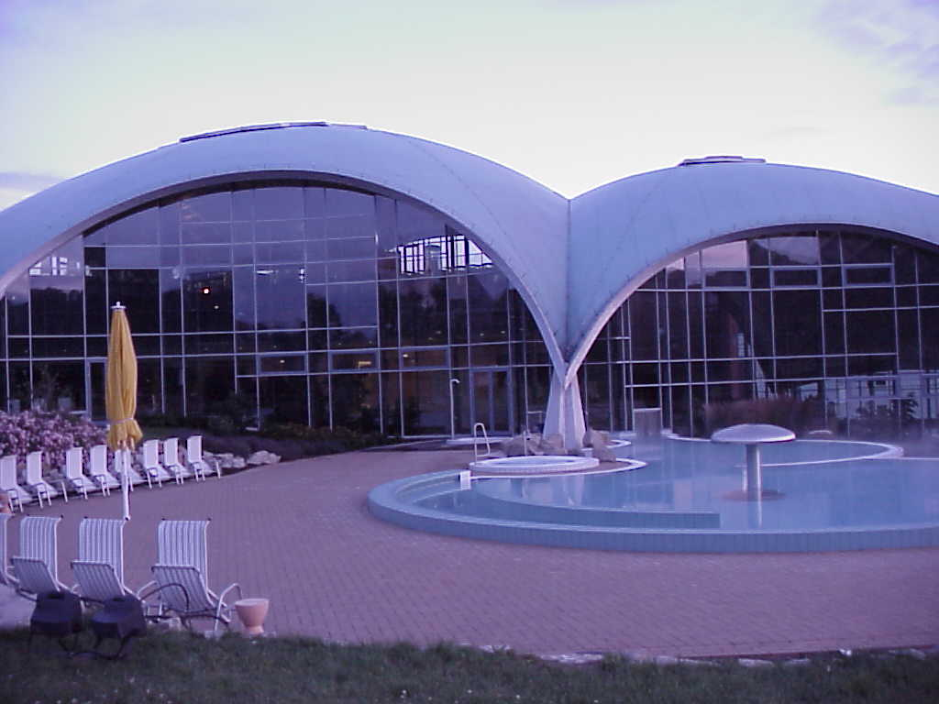 | 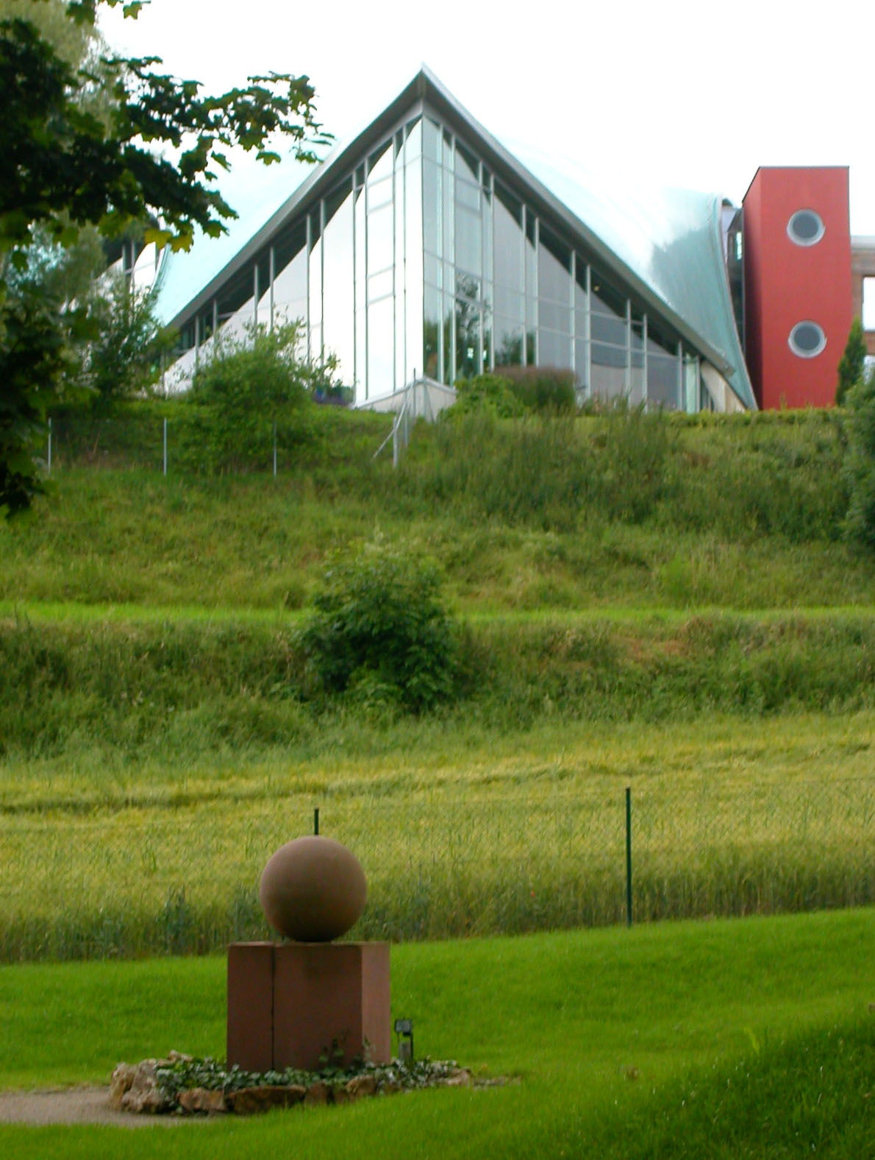

Dr. J. Paul De Vierville, Professor of The Humanities & History

Micky Remann, Liquid Sound Inventor and Cultural Director

Musia Heike Bus, Director, Trainer, Aqua-Wellness Float Keeper

Marion Schneider, Poet, Entrepreneur and CEO Bad Sulza Spa
When: July 10 - 17, 2005  Where: Hotel an der Therme, Bad Sulza, Germany  (site of the World Class Liquid Sound Temple Spa)  E-mail for Details and Costs including full tuition, range of accommodations, meals, entrances & fees)  Seminar languages: English & German | 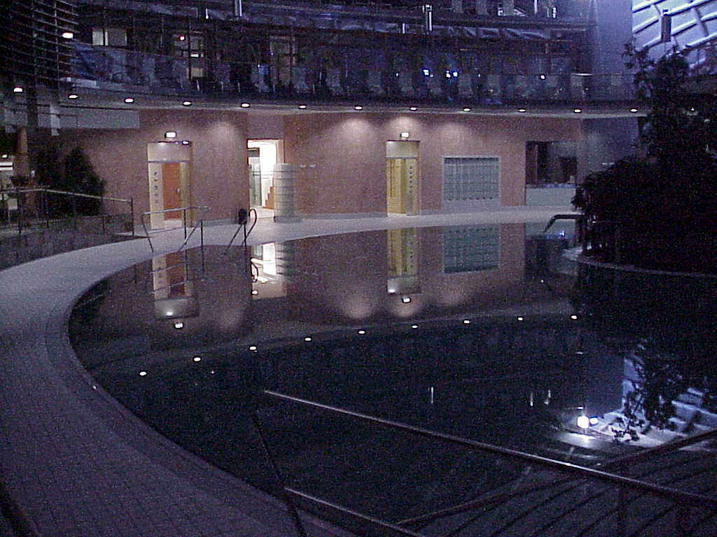
CONTACT information: phone: +210.822.7238 (CST)
www.hotel-an-der-therme.de/englisch/dreamswse.htm
www.aquawellness.com www.liquid-sound.com
www.alamoplazaspa.com/training/germany
Avant-garde Spa Culture Seminar &

The Eco-Social Dreaming Matrix & Liquid Sound Experience

July 10 – 17, 2005
Water is a mystery within us. Water is a universal agent for transition, transformation, healing and balance. Water is soft, sensuous and musical, directly associated with the world of the unconscious and dreams. We are the waters and dreams and the waters and dreams are us.
Participants experience an aquatic journey into their dreams, healing imagination, and cultural creativities through an exploration and revelation of ancient and avant-garde ways. Vital is “The Right Question" at “The Right Time." One is prepared to recall and re-member, acknowledge and absorb the host of spontaneous images, significant symbols, and meaningful myths that emerge while immersed in a watery world of dreaming.
Step-by-step presentations, dialogues and discussions focus on helpful themes including sleep & incubation, labyrinths & motion, oracles & consciousness, time & timing, rites & rituals. Excursions lead onto the fields and parklands and into the healing thermal Spa Waters of Bad Sulza. The sequence, activities and times spent walking, floating, sleeping and dreaming within different realms of consciousness are modeled after ancient Greek healing methods, as practiced at Delphi and the Aesculapian Sanctuary at Epidaurus.
The full Avant-garde Spa Culture program immerses one deeply into eco-social and collective dreams as well as personal visionary discovery through a mirroring of the inner and outer worlds. "The Dream Quest" includes visits to cultural performances in the romantic region of Weimar where Goethe and Rudolf Steiner lived and wrote. The cultural events are unlike anything you have experienced before: for example there is the living Willow Palace of "Auerstedt" and the cultural city of Weimar.
Late evenings participants have private use of "Toskana Therme" and special “Liquid Sound Temple,” for thermal spa bathing in light, sounds, tones and music. Here you experience “Aqua Wellness & Liquid Bodywork.” Thermal spa waters, deep dreams and rhythmic rituals open oneself into a deeper vision of Spa Culture both ancient and futuristic. This is a time for pilgrimage as if to Delphi and Epidaurus where individuals received an inner calling from their own inspirational dreams, cultural imaginations and divine intuitions.
Avant-garde Spa Culture Seminar &

The Eco-Social Dreaming Matrix & Liquid Sound Experience

July 10 – 17, 2005

Day & Night 1 July 11th Monday
Civilization in Transition: Spa Culture & Dream Time,
An Eco-Social-Dreaming Matrix: Theory & Practice of Dreams as Oracular Agencies in the Ancient and Post-modern World
Faculty: Prof. Dr. J Paul De Vierville, Professor of The Humanities
Day & Night 2 July 12th Tuesday
Liquid Sound: Yesterday, Today & Tomorrow
Crossing the threshold to sensual baptism and conscious dying
Faculty: Micky Remann, Liquid Sound Inventor and Cultural Director

Day & Night 3 July 13th Wednesday
Liquid Body Work: Art and Craft of the Buoyant Body and Vibrant Soul, Float-Keeping and Liquid Body Work.
Faculty: Musia Heike Bus, Publisher/Director Institute for AquaWellness

Day & Night 4 July 14th Thursday
Contemporary & Future Spa Culture & Business: Poetic Self-Expression in Classical Weimar and visit to Weimar with conversations on Goethe and Steiner in, around and through Nature & Spirit
Faculty: Marion Schneider, Poet, and CEO & Prof. J Paul De Vierville

Day & Night 5 July 15th Friday
Dream Time & Spa Culture as Sacred Agencies of Transitions, Transformations and Transfigurations of Consciousness through Sacred Geometry & Sacred Sounds
Faculty: Prof. J Paul De Vierville

Day & Night 6 July 16th Saturday
Spa Time, Spa Times & Spa Timing: Dreams, Cycles, Circles & Spheres
Full Faculty for Feedback Floating, Flowing and Futuring

Day 7 July 17th Sunday
Summaries & Full Dream Circle and Departure

Avant-garde Spa Culture Seminar &

The Eco-Social Dreaming Matrix & Liquid Sound Experience

July 10 – 17, 2005

The seven day/six night workshop costs $750 US-Dollar per participant. 50% advance payment is due upon registration/reservation.

The Hotel an der Therme Bad Sulza offers special rates for all workshop participants as follows:

Hotel an der Therme House 1 half board (group rate)
single room per night 84.75 Euro
double room per person and night 62.00 Euro
apartment for 3 or 4 persons
per person and night 52.40 Euro

(House 1 offers include unlimited use of the Toskana Therme during opening hours)

Hotel an der Therme House 3 half board (group rate)
single room per night 56.75 Euro
double room per person and night 48.00 Euro
(House 3 offers: two hours use of the Toskana Therme each overnight)

If participants would like to share a room or apartment with another participant, please contact Dr. Jonathan Paul de Vierville directly for details of other participants: alamospa@mac.com. phone: +210.822.7238 (CST).

A 10 Euro/day workshop room fee is levied for all participants – for Hotel an der Therme residents this fee is included in the room price above.
You may check for alternative accommodation at www.bad-sulza.de.

More contact information can be read on the web at:
http://www.alamoplazaspa.com/training/germany
http://www.hotel-an-der-therme.de/englisch/dreamswse.htm
http://www.aquawellness.com
http://www.liquid-sound.com
http://users.pandora.be/entrance/mens/our_journey.htm

